**Accessing and Using the Azure Cloud Shell SOP**

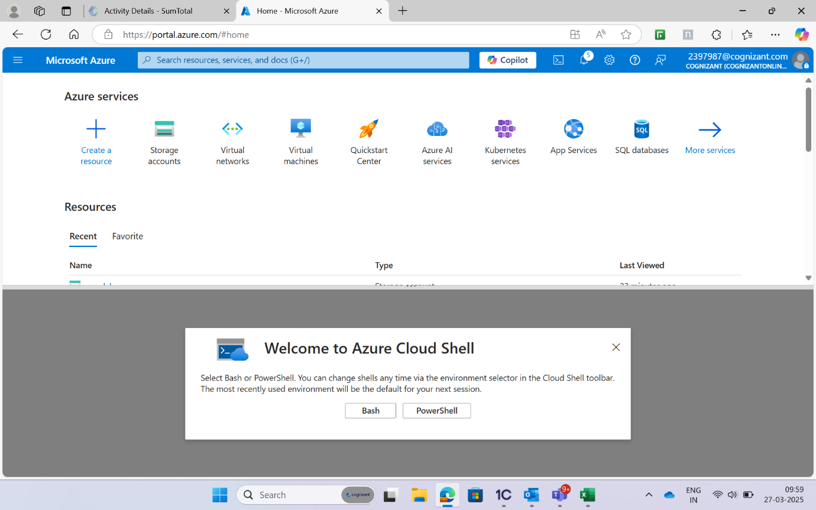

**List the resource groups available in your Azure subscription:**



